**DEP SUBCONTRACTOR PROFILE FORM**

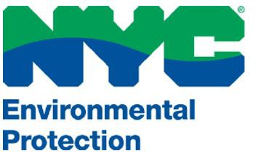

**TO BE COMPLETED BY SUBCONTRACTOR**

INSTRUCTIONS TO PRIME CONTRACTOR

A Subcontractor Profile Form must be completed by EACH subcontractor that will perform on the contract.

Prime Contractor Name: EIN # / SS#:

Contract Number:

Procurement ID # (E-PIN):

**Subcontractor Name:**

**EIN # / SS#:**

**Subcontractor M/WBE Certification**

NYC Small Business Services

MBE

DBE

NYS Empire State Development Corporation

WBE

N/A

**Subcontractor Business Address**

**Number | Street:**

**City:**

**State:** New York

**Phone Number:**

**E-Mail Address:**

**Zip:**

**Are there any subcontractor employees that formerly worked for DEP?**

**Former Employee:** < Select >

**Employee Name:**

**Employee Name:**

**Employee Name:**

Subcontract Amount:

Detailed Description of Subcontractor Work:

Form Completed by: Title:

Signature:

Date:

***Revised: June, 2022***